24CSI024-DATA STRUCTURES AND ALGORITHMS
UNIT 1-INTRODUCTION TO DATA STRUCTURES AND ALGORITHMS
Arrays and Array-Based Techniques (Two-Pointer, Sliding Window, Prefix Sums) LAB WORKBOOK-09.07.2026

CATEGORY: EASY

Question 1: Squaring a Sorted Array (Two-Pointer)
Anjali is processing seismic intensity readings stored in a non-decreasing sorted array. The readings can contain negative values (representing reverse-phase wave intensities) as well as positive values. To calculate the kinetic energy of these waves, she needs to square each value and return a new array containing the squares, sorted in non-decreasing order.
She must perform this operation in 𝑂(𝑁) time using the two-pointer technique:
- Initialize a left pointer at index 0 and a right pointer at index N - 1.
- Compare the absolute values of arr[left] and arr[right].
- Square the larger absolute value and place it at the end of the output array (starting from index N - 1 and moving backwards).
- Move the corresponding pointer (left inward or right inward) and repeat until the output array is filled.
  - The first line of input consists of an integer 𝑁 representing the number of readings.
  - The second line of input consists of 𝑁 space-separated integers representing the sorted wave intensities (can contain negative numbers).
  - Print a single line of 𝑁 space-separated integers representing the sorted squared values.
  - 1 ≤ 𝑁 ≤ 10000
  - −10⁴ ≤ 𝑎𝑟𝑟[𝑖] ≤ 10⁴
  - The input array is sorted in non-decreasing order.

Input 1:
codeText 5
-4 -1 0 3 10

Output 1:
codeText
0 1 9 16 100

Input 2:
codeText 4
-7 -3 2 3

Output 2:
codeText 4 9 9 49

Aim
To write a C program that squares each element of a sorted array (containing negative and positive values) and returns the result as a sorted array, using the two-pointer technique in O(N) time.

Pseudocode
left = 0
right = n - 1

for (k = n - 1; k >= 0; k--)
{
if (abs(arr[left]) > abs(arr[right]))
{
result[k] = arr[left] * arr[left]
left = left + 1
}
else
{
result[k] = arr[right] * arr[right]
right = right – 1
}
}
C Code
#include <stdio.h>
int main() {
int n;
scanf("%d", &n);
int arr[10000], result[10000];
for (int i = 0; i < n; i++) scanf("%d", &arr[i]);
int left = 0, right = n - 1;
for (int k = n - 1; k >= 0; k--) {
int leftSq = arr[left] * arr[left];
int rightSq = arr[right] * arr[right];
if (leftSq > rightSq) {
result[k] = leftSq;
left++;
} else {
result[k] = rightSq;
right--;
}
}
for (int i = 0; i < n; i++) printf("%d ", result[i]);
printf("\n");
return 0;
}
OUTPUT:
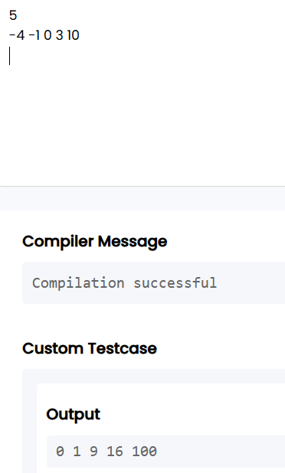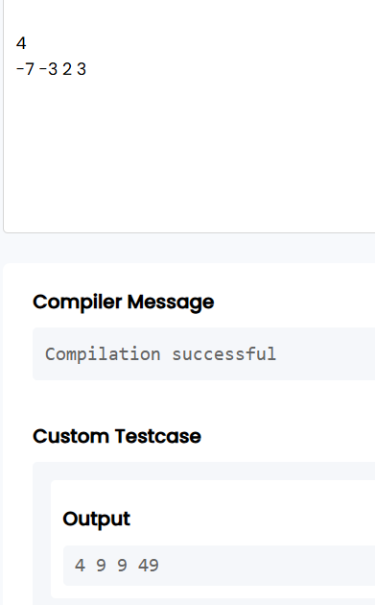

Result:
Thus, a C program to square the elements of a sorted array and return them in sorted order using the two-pointer technique was written, executed, and verified successfully for the given test cases.

Question 2: Cumulative Resource Consumption (Prefix Sum)
Kabir is monitoring a data transmission line. He receives a log of data packets transmitted each hour over a period of 𝑁 hours. To generate an hourly usage report, he wants to compute the cumulative running sum of packets transmitted from the start of the log up to each hour.
Write a program that takes the hourly logs and outputs the prefix sum array representing the cumulative data volume.
  - Let the prefix sum array be P.
  - P[0] = arr[0]
  - P[i] = P[i-1] + arr[i] for 𝑖 ≥ 1.
  - The first line of input consists of an integer 𝑁 representing the number of hours.
The second line consists of 𝑁 space-separated integers representing the packets transmitted each hour.
  - Print a single line of 𝑁 space-separated integers representing the cumulative running sum at each hour.
  - 1 ≤ 𝑁 ≤ 10000
  - 0 ≤ 𝑎𝑟𝑟[𝑖] ≤ 10⁵

Input 1:
codeText 5
10 20 5 15 30

Output 1:
codeText
10 30 35 50 80

Input 2:
codeText 3
0 0 5

Output 2:
codeText 0 0 5

Aim
To write a C program that computes the prefix sum array of N hourly data transmission logs in O(N) time.

Pseudocode
prefix[0] = arr[0]

for (i = 1; i < n; i++)
{
prefix[i] = prefix[i-1] + arr[i]
}
C Code
#include <stdio.h>
int main() {
int n;
scanf("%d", &n);
long arr[10000], prefix[10000];
for (int i = 0; i < n; i++) scanf("%ld", &arr[i]);
prefix[0] = arr[0];
for (int i = 1; i < n; i++)
prefix[i] = prefix[i - 1] + arr[i];
for (int i = 0; i < n; i++) printf("%ld ", prefix[i]);
printf("\n");
return 0;
}
OUTPUT:
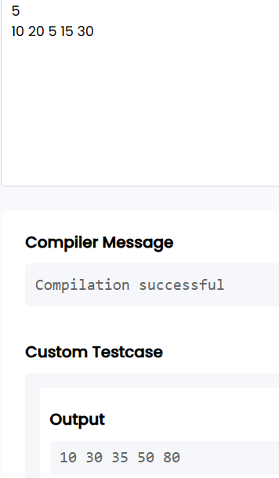
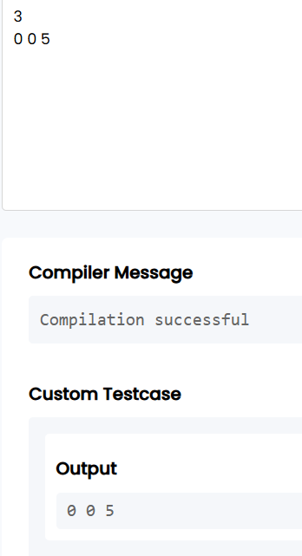

Result:
Thus, a C program to compute the prefix sum array representing the cumulative data volume was written, executed, and verified successfully for the given test cases.

CATEGORY: MEDIUM

Question 3: Grouping Active Sectors (Fixed-Size Sliding Window)
Sam is working on a flash storage defragmentation algorithm. The sectors of the storage drive are represented by a binary array of size 𝑁, where 1 represents an active data sector and 0 represents an empty sector. To optimize read operations, Sam wants to group all active sectors (1s) together in a contiguous block.
He wants to find the minimum number of swaps required to bring all 1s together. This can be solved in 𝑂(𝑁) time using a sliding window:
- Count the total number of 1s in the array. Let this count be 𝐶. If 𝐶 is 0 or 1, no swaps are needed.
- Find a contiguous subarray (window) of size 𝐶 that contains the maximum number of 1s.
- The minimum number of swaps required is then 𝐶 minus the maximum number of 1s found in any window of size 𝐶.
  - The first line of input consists of an integer 𝑁 representing the number of sectors.
  - The second line of input consists of 𝑁 space-separated binary values (0 or 1).
  - Print a single integer representing the minimum swaps required in the format: Min Swaps: X.
  - 1 ≤ 𝑁 ≤ 10000
  - arr[i] is either 0 or 1.
Input 1: codeText 6
1 0 1 0 1 0

Output 1:
codeText
Min Swaps: 1
Input 2: codeText 5
1 1 1 0 0

Output 2:
codeText
Min Swaps: 0

Aim
To write a C program that finds the minimum number of swaps required to group all 1s together in a binary array, using a fixed-size sliding window of size equal to the count of 1s.

Pseudocode

ones = 0
for (i = 0; i < n; i++)
{
if (arr[i] == 1)
ones = ones + 1
}

if (ones == 0 || ones == 1)
swaps = 0

windowOnes = 0
for (i = 0; i < ones; i++)
{
windowOnes = windowOnes + arr[i]
}

maxOnes = windowOnes

for (i = ones; i < n; i++)
{
windowOnes = windowOnes + arr[i] - arr[i - ones]
if (windowOnes > maxOnes)
maxOnes = windowOnes
}
swaps = ones - maxOnes

C Code
#include <stdio.h>
int main() {
int n;
scanf("%d", &n);
int arr[10000];
int ones = 0;
for (int i = 0; i < n; i++) {
scanf("%d", &arr[i]);
if (arr[i] == 1) ones++;
}

if (ones == 0 || ones == 1) {
printf("Min Swaps: 0\n");
return 0;
}

int windowOnes = 0;
for (int i = 0; i < ones; i++) windowOnes += arr[i];

int maxOnes = windowOnes;
for (int i = ones; i < n; i++) {
windowOnes += arr[i] - arr[i - ones];
if (windowOnes > maxOnes) maxOnes = windowOnes;
}

printf("Min Swaps: %d\n", ones - maxOnes);
return 0;
}
OUTPUT:
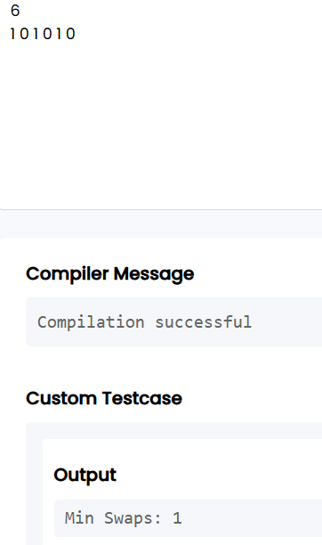
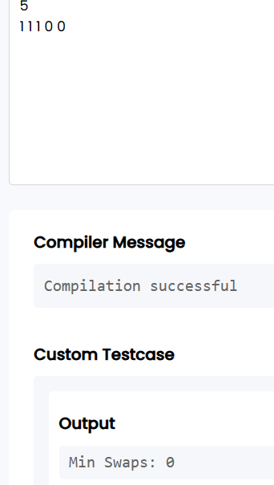

Result:
Thus, a C program to find the minimum number of swaps required to group all active sectors together using the fixed-size sliding window technique was written, executed, and verified successfully for the given test cases.

Question 4: Maximum Task Window Within Budget (Variable-Size Sliding Window)
Riya is scheduling a pipeline of processes on an embedded processor. Each process 𝑖 has a known energy cost arr[i]. The processor has a strict power limit 𝑃 for any contiguous execution sequence. Riya wants to find the maximum number of consecutive tasks she can execute without their combined energy cost exceeding the limit 𝑃.
She uses a variable-size sliding window:
- Maintain a start pointer at index 0 and a running sum of energy current_sum.
- Iterate an end pointer from 0 to N - 1 and add arr[end] to current_sum.
- If current_sum exceeds 𝑃,increment start and
subtract arr[start] from current_sum until current_sum <= P.
- Keep track of the maximum window size (end - start + 1) encountered during the process.
  - The first line of input consists of two space-separated integers: 𝑁 (the number of tasks) and 𝑃 (the maximum allowed energy consumption).
  - The second line of input consists of 𝑁 space-separated positive integers representing the
energy costs of the tasks.
  - Print a single integer representing the maximum consecutive tasks in the format: Max Length: X.
  - 1 ≤ 𝑁 ≤ 10000
  - 1 ≤ 𝑎𝑟𝑟[𝑖] ≤ 10⁴
  - 1 ≤ 𝑃 ≤ 10⁸

Input 1:
codeText 5 8
3 1 2 4 5

Output 1:
codeText
Max Length: 3

Input 2:
codeText 4 5
6 7 8 9

Output 2:
codeText
Max Length: 0

Aim
To write a C program that finds the maximum number of consecutive tasks that can be executed without their combined energy cost exceeding a given power limit P, using a variable-size sliding window.

Pseudocode

start = 0
currentSum = 0
maxLen = 0

for (end = 0; end < n; end++)
{
currentSum = currentSum + arr[end]

while (currentSum > P && start <= end)
{
currentSum = currentSum - arr[start]
start = start + 1
}

if (currentSum <= P && (end - start + 1) > maxLen)
maxLen = end - start + 1
}

C Code
#include <stdio.h>
int main() {
int n;
long P;
scanf("%d %ld", &n, &P);
long arr[10000];
for (int i = 0; i < n; i++) scanf("%ld", &arr[i]);

int start = 0, maxLen = 0;
long currentSum = 0;

for (int end = 0; end < n; end++) {
currentSum += arr[end];
while (currentSum > P && start <= end) {
currentSum -= arr[start];
start++;
}
int len = end - start + 1;
if (currentSum <= P && len > maxLen) maxLen = len;
}

printf("Max Length: %d\n", maxLen);
return 0;
}
OUTPUT:
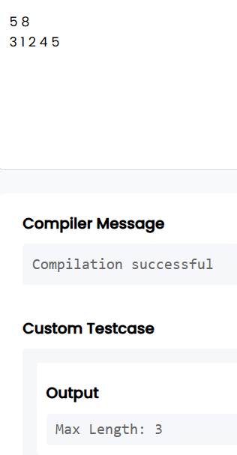
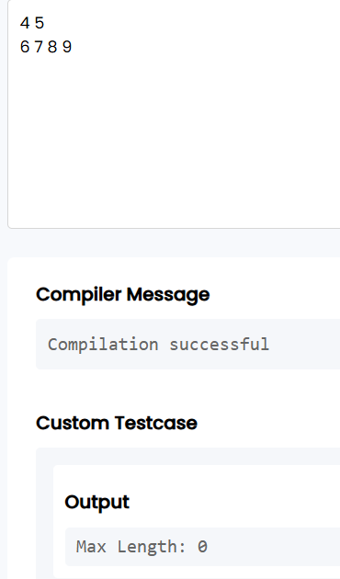

Result:
Thus, a C program to find the maximum number of consecutive tasks executable within the given power budget using the variable-size sliding window technique was written, executed, and verified successfully for the given test cases.

CATEGORY: HARD

Question 5: Sliding Window Maximum Peak (Monotonic Window Queue)
Rohan is building a real-time graphics rendering system. The system receives a sequence of frame rendering times. To smooth out frame drops, Rohan must calculate the peak (maximum) rendering time in every sliding window of 𝐾 consecutive frames.
To achieve an optimal 𝑂(𝑁) runtime, Rohan uses a monotonic double-ended queue (deque) to store indices of elements in the sliding window:
- As the window slides from left to right, maintain the deque such that indices of elements are stored in decreasing order of their corresponding values.
- For each element arr[i]:
  - Remove indices from the back of the deque if their corresponding values are less than or equal to the current element arr[i] (they can no longer be the maximum).
  - Insert the current index i at the back of the deque.

  - Remove the index from the front of the deque if it falls outside the bounds of the current sliding window (i.e., if the index is less than i - K + 1).
- For every step where the window is fully formed (when i >= K - 1), the element at the index stored at the front of the deque is the maximum for that window.
Note: Since standard C does not have a built-in deque, you can implement a basic deque using a pre-allocated array of size 𝑁 with front and rear pointer indices.
- The first line of input consists of two space-separated integers: 𝑁 (the total number of frames) and 𝐾 (the sliding window size).
- The second line of input consists of 𝑁 space-separated integers representing the frame
rendering times.
- Print a single line of space-separated integers representing the maximum value for each sliding window of size 𝐾.
- 1 ≤ 𝐾 ≤ 𝑁 ≤ 10000
- −10⁵ ≤ 𝑎𝑟𝑟[𝑖] ≤ 10⁵

Input 1:
codeText 8 3
1 3 -1 -3 5 3 6 7

Output 1:
codeText 3 3 5 5 6 7

Input 2:
codeText 4 2
4 3 2 1

Output 2:
codeText 4 3 2

Aim
To write a C program that finds the maximum value in every sliding window of size K in an array of N elements in O(N) time, using a monotonic deque implemented with an array.
Pseudocode

front = 0
rear = -1

for (i = 0; i < n; i++)
{
while (rear >= front && arr[deque[rear]] <= arr[i])
rear = rear - 1

rear = rear + 1
deque[rear] = i

if (deque[front] < i - k + 1)
front = front + 1

if (i >= k - 1)
maxOfWindow = arr[deque[front]]
}

C Code
#include <stdio.h>
int main() {
int n, k;
scanf("%d %d", &n, &k);
int arr[10000];
for (int i = 0; i < n; i++) scanf("%d", &arr[i]);

int deque[10000];
int front = 0, rear = -1;

for (int i = 0; i < n; i++) {
while (rear >= front && arr[deque[rear]] <= arr[i]) rear--;
deque[++rear] = i;

if (deque[front] < i - k + 1) front++;

if (i >= k - 1) printf("%d ", arr[deque[front]]);
}
printf("\n");
return 0;
}
OUTPUT:

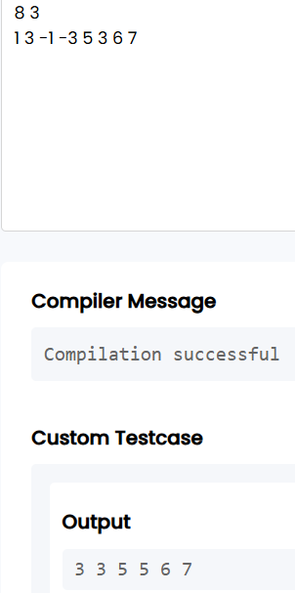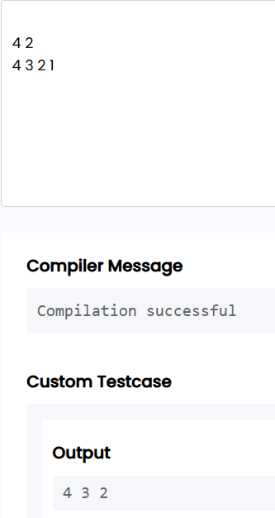

Result:
Thus, a C program to find the maximum value in every sliding window of size K using a monotonic deque was written, executed, and verified successfully for the given test cases.

VIVA QUESTIONS:

- "We often describe a 'List' or a 'Queue' as an Abstract Data Type (ADT), while an 'Array' is a concrete data structure. In C, which lacks native object-oriented classes, how do we enforce the separation between an ADT's interface and its underlying array implementation?"

An ADT (Abstract Data Type) defines what operations can be done, while an array is the actual implementation. In C, we separate them using functions and header files.

- "When using the two-pointer approach to find a pair with target sum 𝑇 in a sorted array, we increment left if the sum is too small, and decrement right if the sum is too large. Intuitively, why are we guaranteed not to 'miss' the correct pair by skipping elements? Why is backtracking unnecessary?"

Since the array is sorted, moving the left pointer increases the sum, and moving the right pointer decreases the sum. So, no valid pair is skipped.

- "If we are given an unsorted array and asked to find a target sum pair, we have two main options: sort the array first and use two pointers, or use a lookup table (hash map). How do you evaluate the trade-offs between these two approaches in a resource-constrained embedded system?"
Sort + Two Pointers: Uses less memory but takes more time due to sorting.Hash Map: Faster but needs extra memory.In embedded systems, Sort + Two Pointers is usually preferred because memory is limited.

- "Why does the classic variable-size sliding window technique (expanding end and contracting start) fail to find a subarray summing to 𝑆 if the input array contains negative integers?"

Negative numbers break the monotonic increase/decrease of the running sum as the window expands/contracts, so the greedy expand-or-shrink logic can miss the valid subarray.

- "Prefix sum arrays allow us to perform range sum queries in 𝑂(1) time. However, what is the computational cost of updating a single element in the original array if we want to keep our prefix sum array valid, and how does this affect our choice of data structure?"

Updating one element costs O(n) to fix all subsequent prefix sums, so for frequent updates a Fenwick tree/segment tree (O(log n) update and query) is preferred over a plain prefix sum array.

- "When passing an array to a C function that implements a sliding window algorithm, what actually gets passed to the function? Why can't we use the sizeof operator inside the function to determine the size of our window or array?"

Only a pointer to the first element is passed (array decays to pointer), so sizeof returns the pointer's size, not the array's — the size must be passed explicitly as a parameter.

- "What major runtime vulnerability or logic error can occur when constructing a prefix sum array of a large dataset of integers in C, even if the individual elements fit within standard data types? How do we mitigate this?"

Cumulative sums can overflow the int type (undefined behavior) even if individual elements are small, so prefix sums should be stored in a wider type like long long/int64_t

- "Suppose you are designing a heart rate monitor. Contrast a scenario where you would use a fixed-size sliding window with a scenario where you would use a variable-size sliding window on the sensor data."

Use a fixed-size window for regular time-based smoothing (e.g., 5-second moving average heart rate), and a variable-size window for detecting data-driven events (e.g., longest duration heart rate stays abnormal).

- "In the 'Sliding Window Maximum' problem (Hard), why can we safely discard an index 𝑗 from the back of our monotonic deque when a new element at index 𝑖 (𝑖 > 𝑗) is introduced such that arr[i] >= arr[j]?"

Because arr[i] >= arr[j] with i > j means j will expire from the window no later than i while never being larger, so j can never again be the maximum and is safely discarded.

- "If we wanted to calculate the average brightness of any arbitrary sub-rectangle of an image in 𝑂(1) time, how would you extend the concept of a 1D prefix sum array to a 2D grid? What would a single 'cell' in the 2D prefix sum represent?"

Define P[i][j] as the cumulative sum of all pixels from (0,0) to (i,j), then any rectangle's sum is computed in O(1) via inclusion-exclusion: P[r2][c2] - P[r1-1][c2] - P[r2][c1-1] + P[r1-1][c1-1].

